Dag 1 2 september
Start 9.00 uur
Gameren
1e stop, veerpont Tiel, drinken bij de auto 27 km

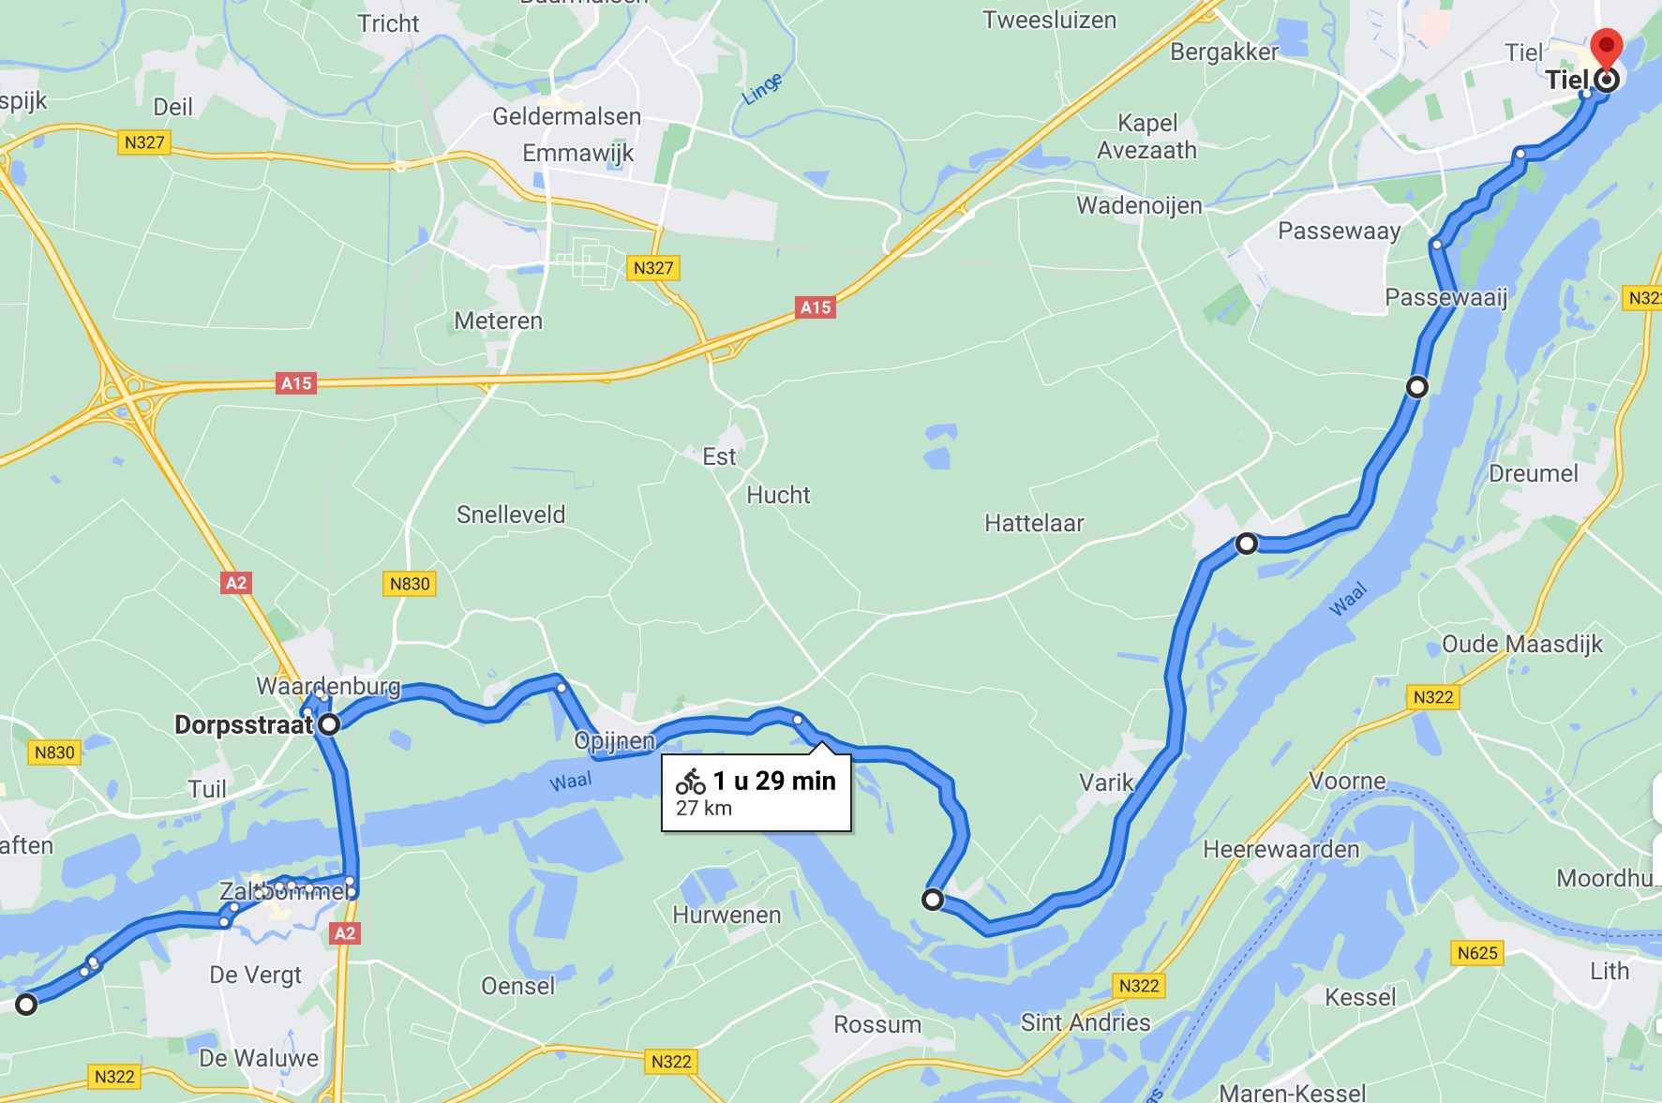
https://www.google.nl/maps/dir/Beemstraat+38,+Gameren,+Nederland/51.8380997,5.2769599/51.8851871,5.4395236/@51.8965197,5.4540517,15z/data=!4m60!4m59!1m5!1m1!1s0x47c6f341c47fa237:0x543400ac6fbe84f0!2m2!1d5.2138764!2d51.8035763!1m50!3m4!1m2!1d5.3457285!2d51.8123295!3s0x47c6f12a5c775afb:0xd0b7a8d8e2e52eb!3m4!1m2!1d5.3858535!2d51.8437846!3s0x47c6f76dd8d023f9:0xcb0e573438168261!3m4!1m2!1d5.3881438!2d51.8443069!3s0x47c6f76e14455437:0x55fb2689187f63e1!3m4!1m2!1d5.388454!2d51.8444456!3s0x47c6f76e14455437:0x55fb2689187f63e1!3m4!1m2!1d5.388454!2d51.8444456!3s0x47c6f76e14455437:0x55fb2689187f63e1!3m4!1m2!1d5.4001448!2d51.8457319!3s0x47c6f77b5052d699:0x19740560b874c15a!3m4!1m2!1d5.4127324!2d51.8587087!3s0x47c6f82bb1ea2451:0x8dcd43a6a8c7cdf2!3m4!1m2!1d5.4132795!2d51.8606494!3s0x47c6f8296eb617d7:0x8705f4cae95e58dd!3m4!1m2!1d5.4172554!2d51.8654528!3s0x47c6f8266e17cda1:0xdc84f2f0688ff493!3m4!1m2!1d5.4199378!2d51.8773266!3s0x47c6f81845666355:0x1b2f9082d2b83fdc!1m0!3e1?hl=nl

2e stop, Lunch Het oude postkantoor 54 km
Dorpstraat 2
Bennekom

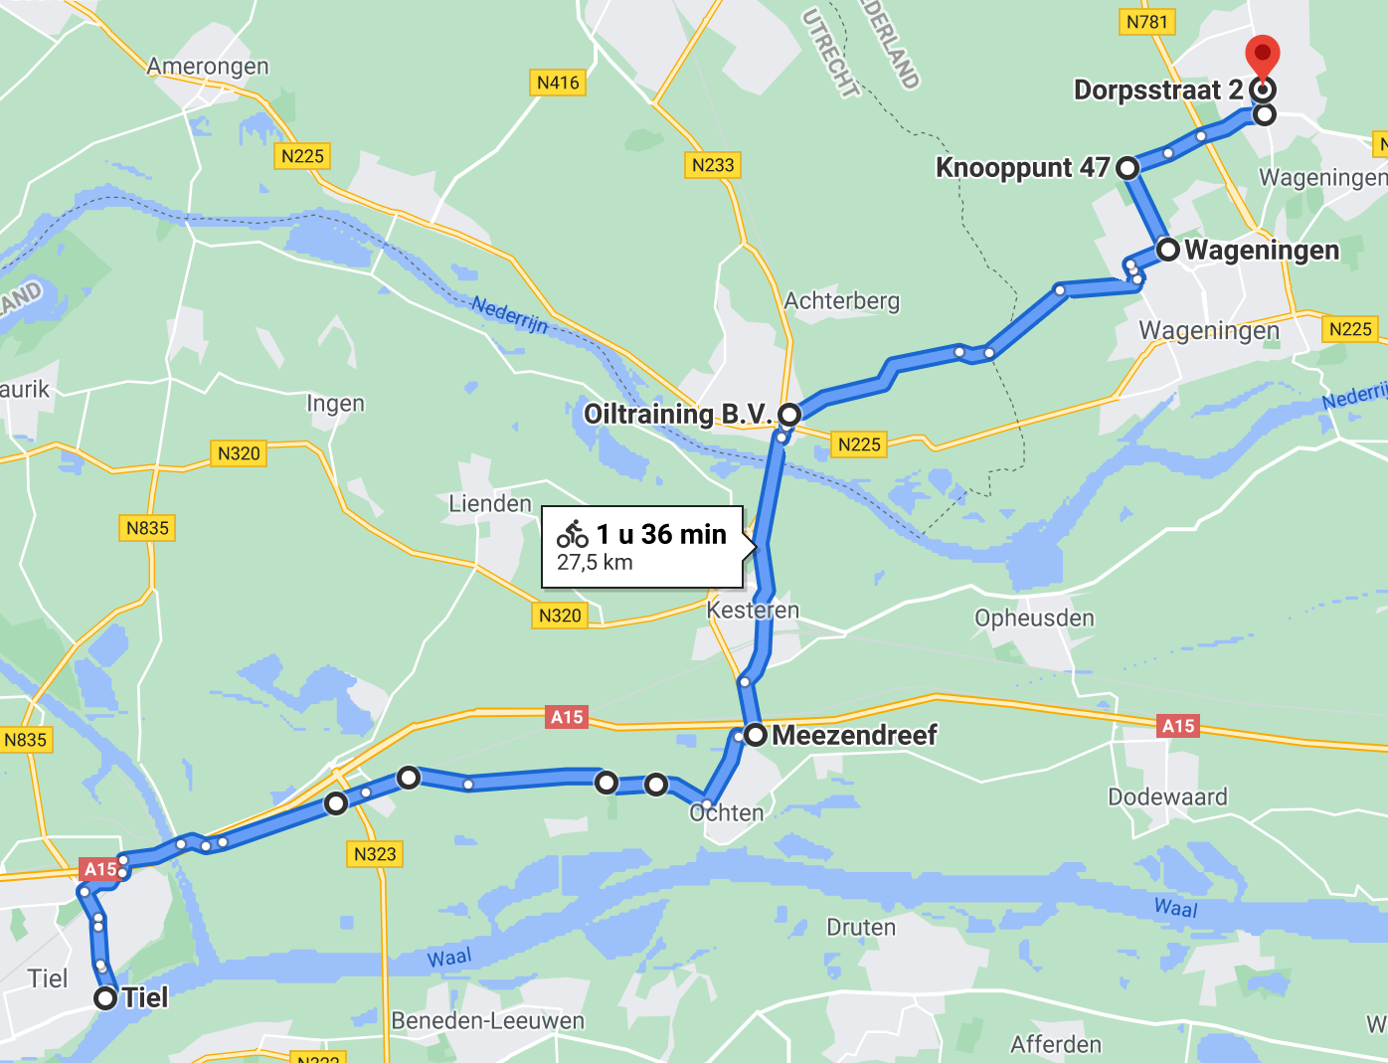

https://www.google.nl/maps/dir/51.8852191,5.43967/51.9183302,5.5725225/51.958809,5.579311/51.9794606,5.6568994/Knooppunt+47/51.9964747,5.6765839/51.9995384,5.6760928/@51.9430452,5.4898824,11.76z/data=!4m54!4m53!1m40!3m4!1m2!1d5.4354982!2d51.8985274!3s0x47c657e231ddd65f:0x2e8ecf659d9ebf73!3m4!1m2!1d5.4868441!2d51.9097675!3s0x47c65630c0d381c3:0x8de42a52b62dfec9!3m4!1m2!1d5.4980011!2d51.9121711!3s0x47c6563fcd97509b:0xc42d55bc3272984d!3m4!1m2!1d5.5017661!2d51.9130149!3s0x47c656151f6444fd:0x467a4d042ca464c4!3m4!1m2!1d5.5421475!2d51.9122856!3s0x47c655e9d9de8c8d:0x98c2e2d6394f9305!3m4!1m2!1d5.5523108!2d51.9121686!3s0x47c655c000480d17:0x7e427db7c617896!3m4!1m2!1d5.5674111!2d51.9151912!3s0x47c655a36bf96fe3:0xa332a000378f2f29!3m4!1m2!1d5.5685045!2d51.9175426!3s0x47c655a48546be77:0x14a362c16e33c535!1m0!1m0!1m0!1m5!1m1!1s0x47c7acb51ffbbc35:0x71919b65b94509db!2m2!1d5.6485659!2d51.989743!1m0!1m0!3e1?hl=nl

3e stop, drinken bij de auto (alternatief bij restaurant of een ijsje) 75-80 km
Hoofdstraat 181 Voorthuizen
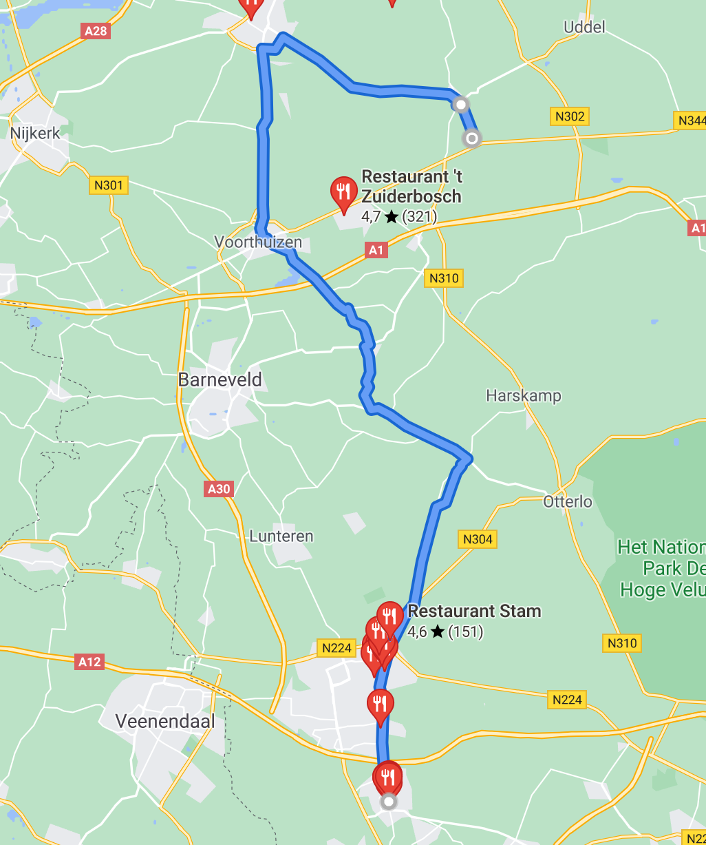
3e stop
https://www.google.com/maps/dir/Dorpsstraat+2,+6721+JK+Bennekom/Oud+Milligenseweg+2,+Garderen/Oud+Milligenseweg+62,+3886+MJ+Garderen/@52.2189936,5.5874054,12.28z/data=!4m30!4m29!1m15!1m1!1s0x47c7ace82f35312f:0x1b3c664dbee93ea1!2m2!1d5.6758564!2d51.9995317!3m4!1m2!1d5.6632709!2d52.1514334!3s0x47c64b5ad4aac101:0x2e504bd6f0054220!3m4!1m2!1d5.6072805!2d52.2504337!3s0x47c635c2a5acb9f7:0xc34cc43c4fe9a161!1m5!1m1!1s0x47c7caa4931d538b:0xf26e661c8750c3f7!2m2!1d5.7151057!2d52.2320123!1m5!1m1!1s0x47c7b56078445e89:0x9c94a9431650b2d1!2m2!1d5.7211048!2d52.2208325!3e1

Aankomst Westford Hotel 97 km
Oud Milligenseweg 62
Garderen
Zwembroek meenemen
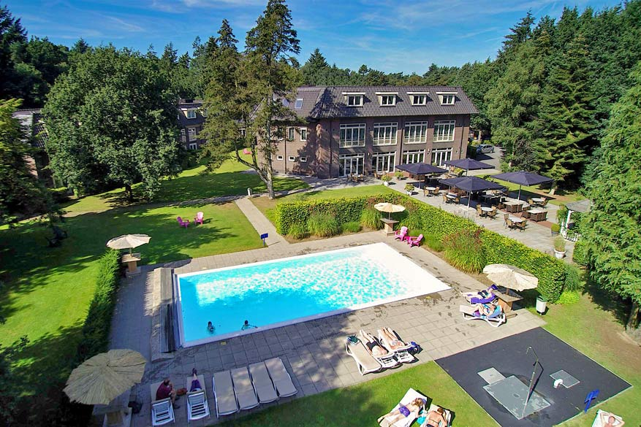

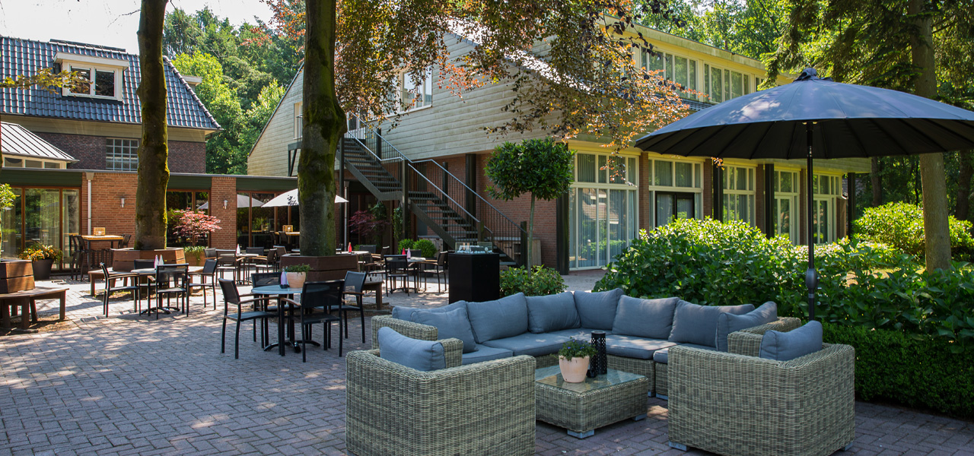

Dag 2 3 september
1e stop bij de haven in Elburg 29,3 km
Drinken bij de auto of?
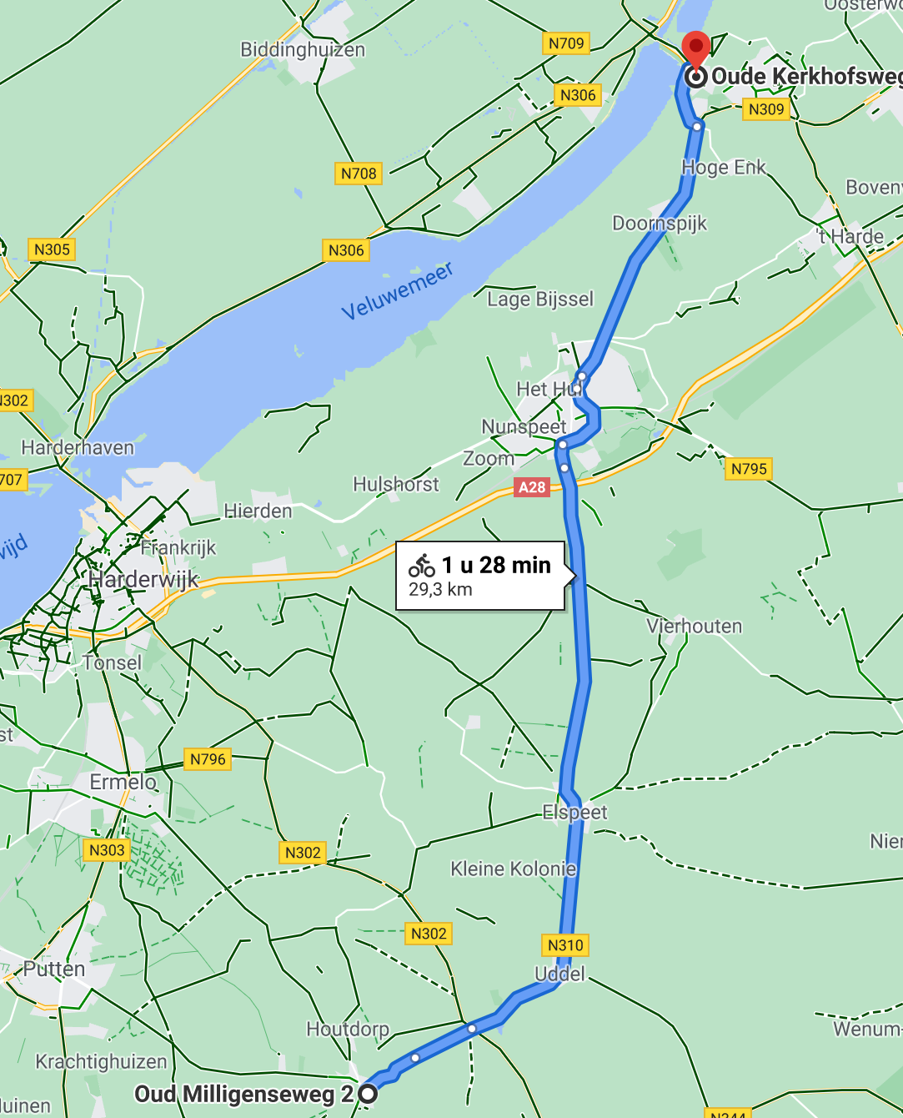
https://www.google.com/maps/dir/Oud+Milligenseweg+2,+Garderen/52.4497699,5.8304407/@52.3916862,5.6305784,11.4z/data=!4m14!4m13!1m10!1m1!1s0x47c7caa4931d538b:0xf26e661c8750c3f7!2m2!1d5.7151057!2d52.2320123!3m4!1m2!1d5.8258462!2d52.4480494!3s0x47c7d3c6d4d18903:0xae5aacf9bdefd3ab!1m0!3e1!5m1!1e3

2e stop, Lunch, Cafe Billard Anno 30 km
Zwolseweg 275
Wenum-Wiesel (bij Apeldoorn)
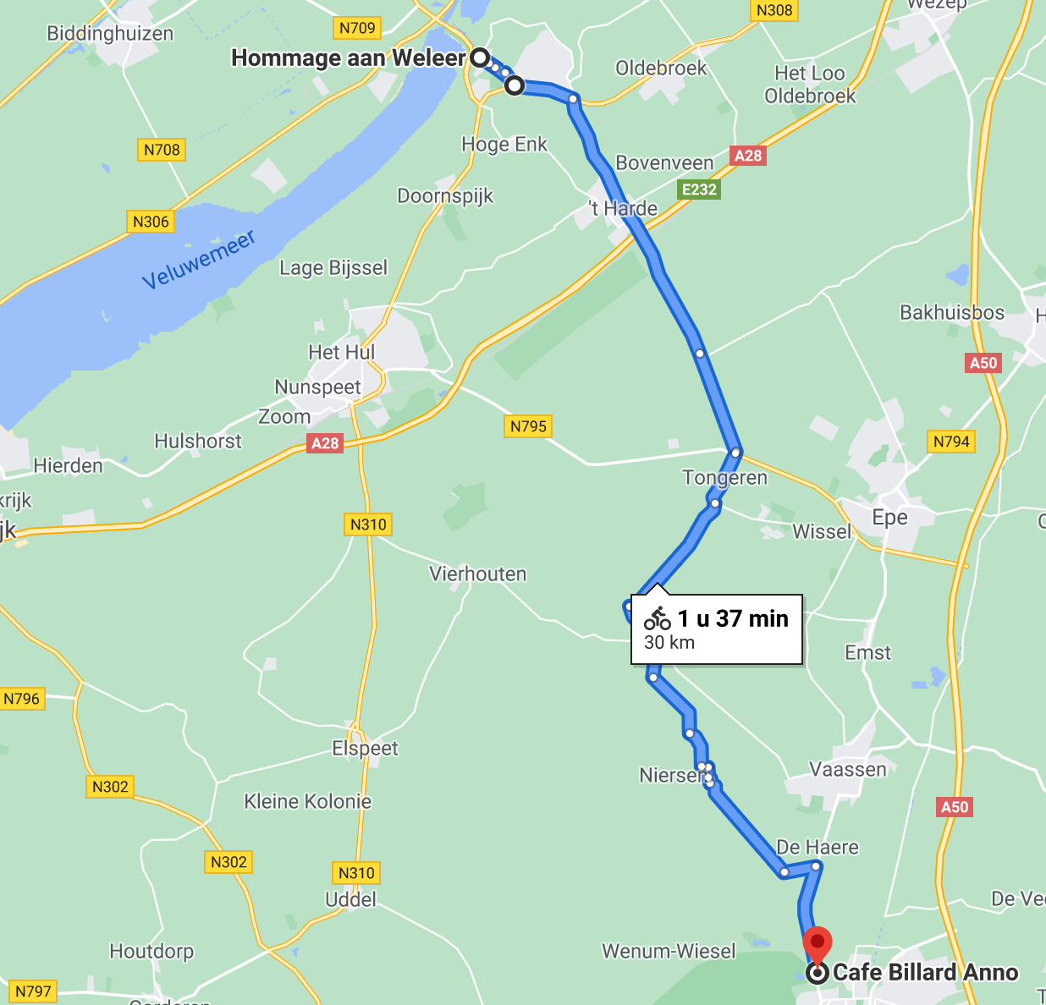
https://www.google.com/maps/dir/Hommage+aan+Weleer,+Elburg/Cafe+Billard+Anno,+Zwolseweg,+Wenum Wiesel/@52.3455961,5.7533917,11z/data=!3m1!4b1!4m29!4m28!1m20!1m1!1s0x47c7d3c3cd364069:0x8190e782039834b5!2m2!1d5.8305209!2d52.4497206!3m4!1m2!1d5.8362829!2d52.4474931!3s0x47c7d3dcb24216a7:0x93613ddc7f6ecd6c!3m4!1m2!1d5.8404552!2d52.4457368!3s0x47c7d3db8df67961:0x9b7d26a739063a24!3m4!1m2!1d5.8433633!2d52.4434647!3s0x47c7d3d99f3c08b7:0x8b5ed6b898e9964d!1m5!1m1!1s0x47c7c7a51afbcd3f:0xc3766a892a325a9a!2m2!1d5.9563505!2d52.2410948!3e1

3e stop Loenen Hoofdstraat Parkeerplaats tegenover de kerk, drinken bij de auto 75 km
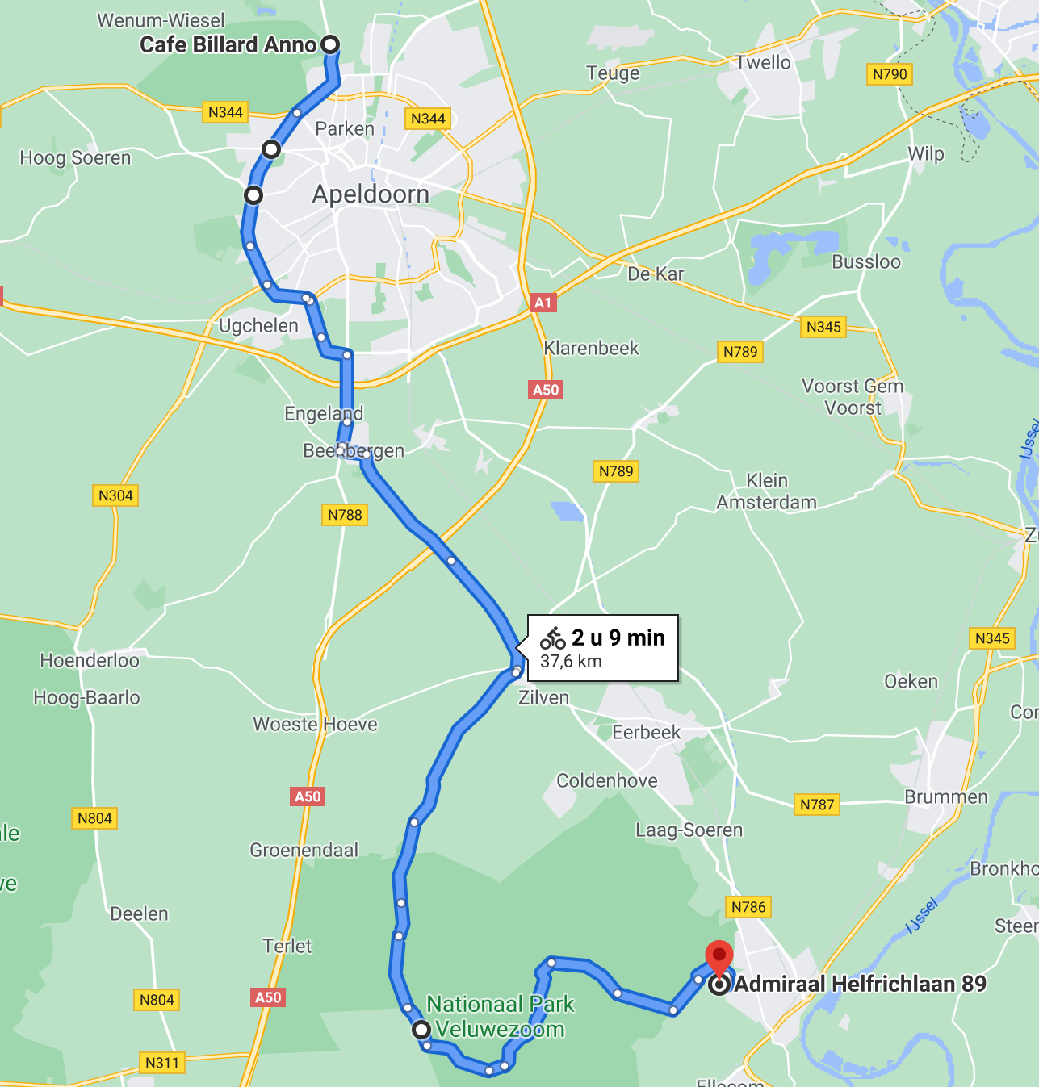
3e stop
https://www.google.com/maps/dir/Cafe+Billard+Anno,+Zwolseweg,+Wenum-Wiesel/Admiraal+Helfrichlaan+89,+Dieren/@52.1466756,5.907379,11.38z/data=!4m29!4m28!1m20!1m1!1s0x47c7c7a51afbcd3f:0xc3766a892a325a9a!2m2!1d5.9563505!2d52.2410948!3m4!1m2!1d5.9371923!2d52.2200757!3s0x47c7c78cd8c9fe35:0x823a45e17223e31d!3m4!1m2!1d5.9313077!2d52.2108808!3s0x47c7b80af2432a71:0x98cd2f91ba7a2eda!3m4!1m2!1d5.986319!2d52.0433947!3s0x47c7bca9683a4b63:0xec219df301874a94!1m5!1m1!1s0x47c7bd5ef0fa700b:0x9a2de23d6c6e75ad!2m2!1d6.0836138!2d52.0525329!3e1

Aankomst Chalethotel polysport 97 km
Admiraal Helfrichlaan 89
Dieren
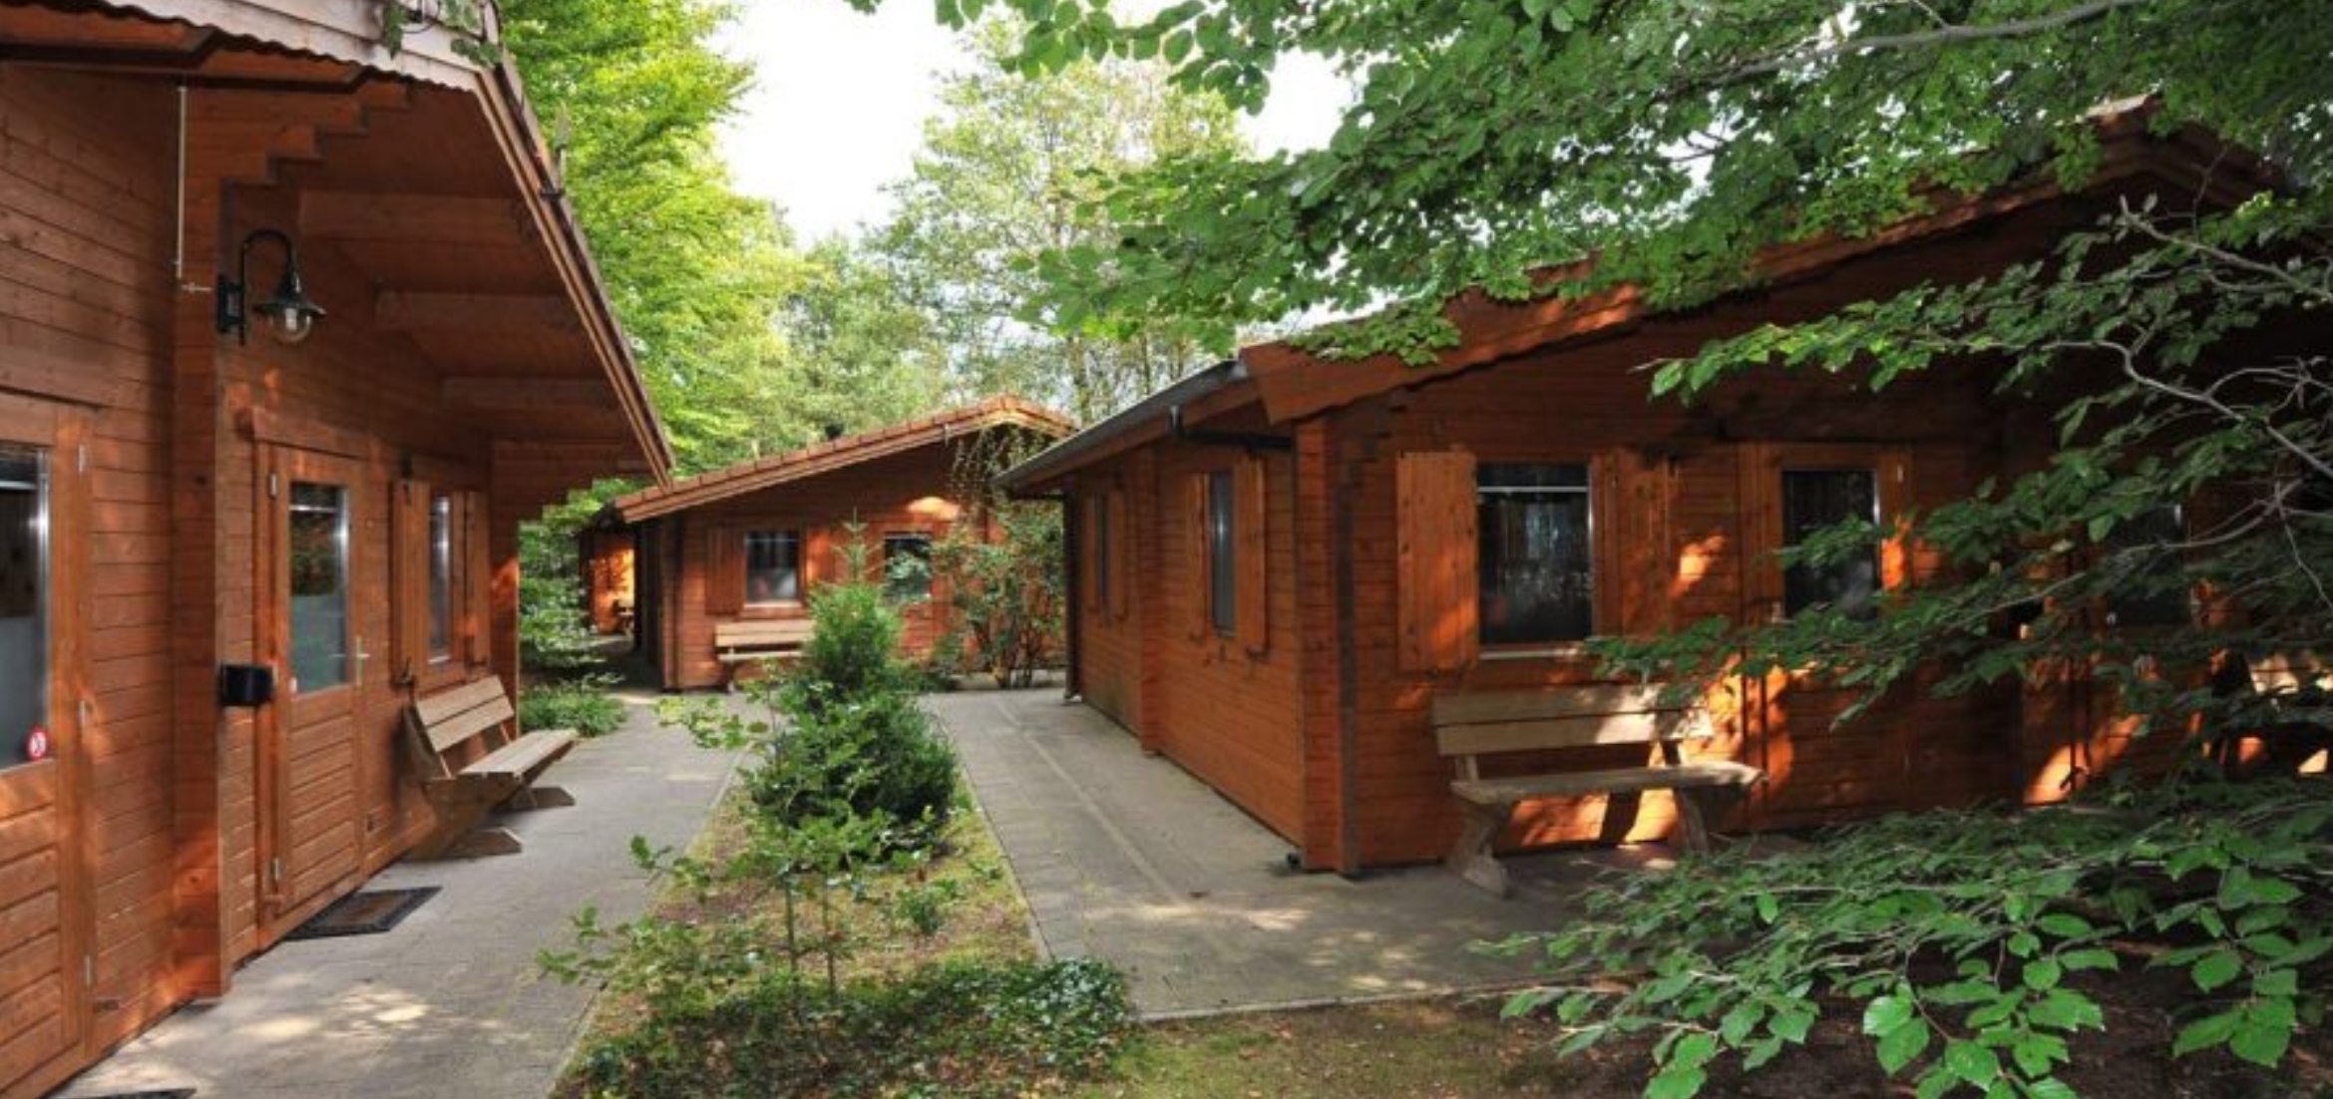
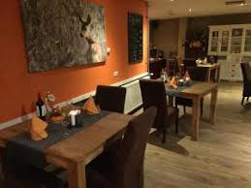

Dag 3 4 september
1e stop net na station Wolfheze 27,7 km
Drinken bij de auto of?
Pleintje voor pannenkoekenhuis “de Tijd”
Wolfhezerweg 87, 6874 AC Wolfheze
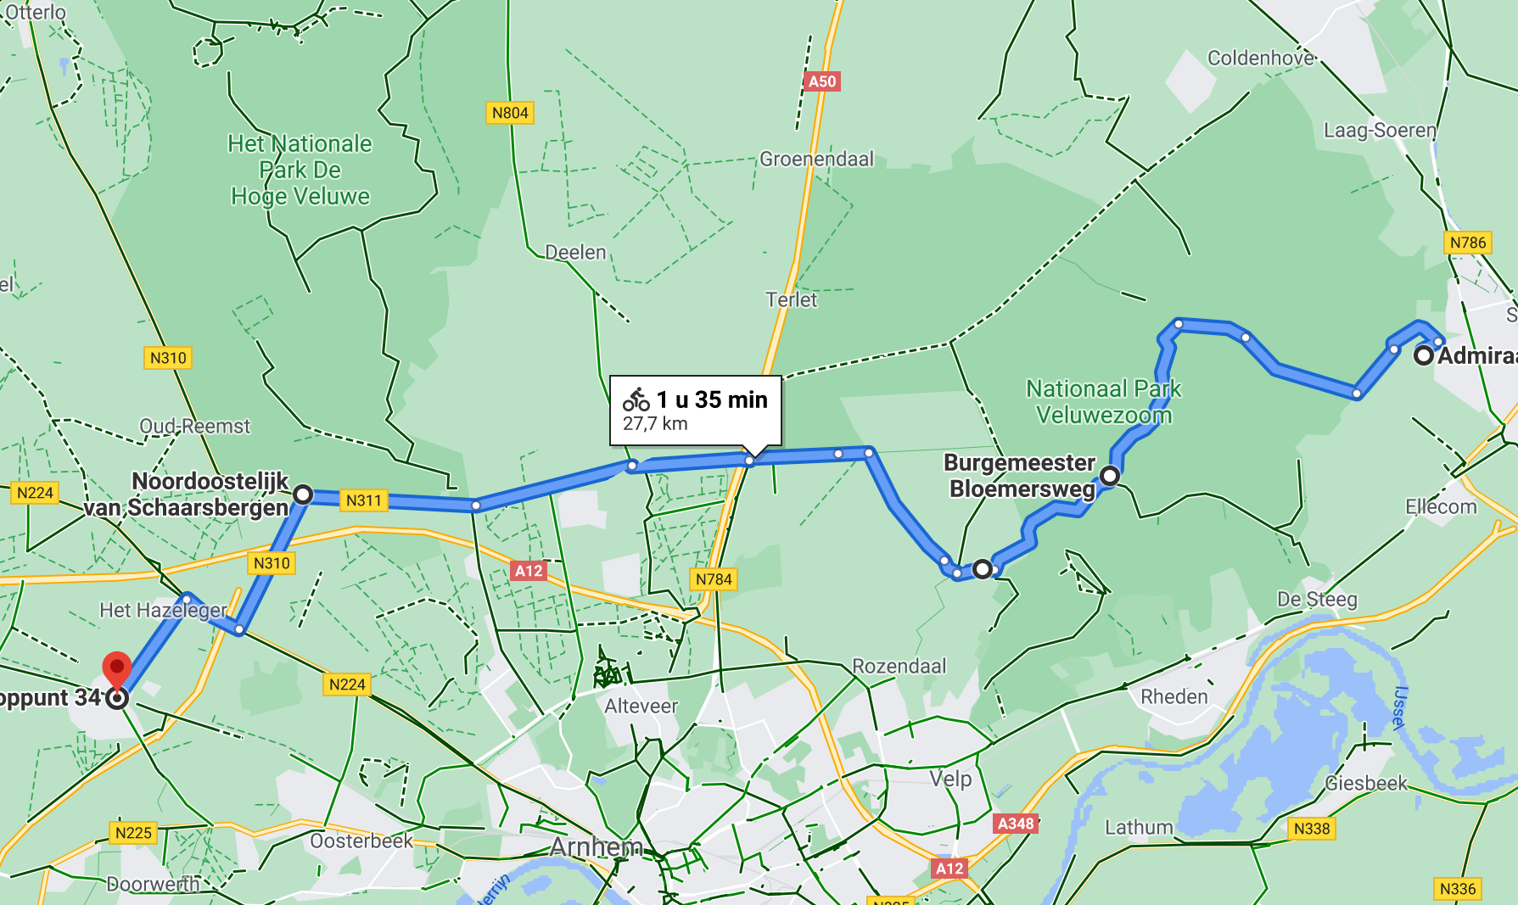
https://www.google.com/maps/dir/Admiraal+Helfrichlaan+89,+Dieren/52.0360302,6.0133852/52.0334635,5.8331082/52.0054564,5.7917551/@52.032538,5.8517106,11.86z/data=!4m16!4m15!1m5!1m1!1s0x47c7bd5ef0fa700b:0x9a2de23d6c6e75ad!2m2!1d6.0836138!2d52.0525329!1m5!3m4!1m2!1d5.9850048!2d52.0232405!3s0x47c7a35c9b881805:0xfccad3b56526da4f!1m0!1m0!3e1!5m1!1e3

2e stop Lunch Uitbaeterij De Viersprong, 33,5 km
Grootestraat 44, 6634 AD Batenburg
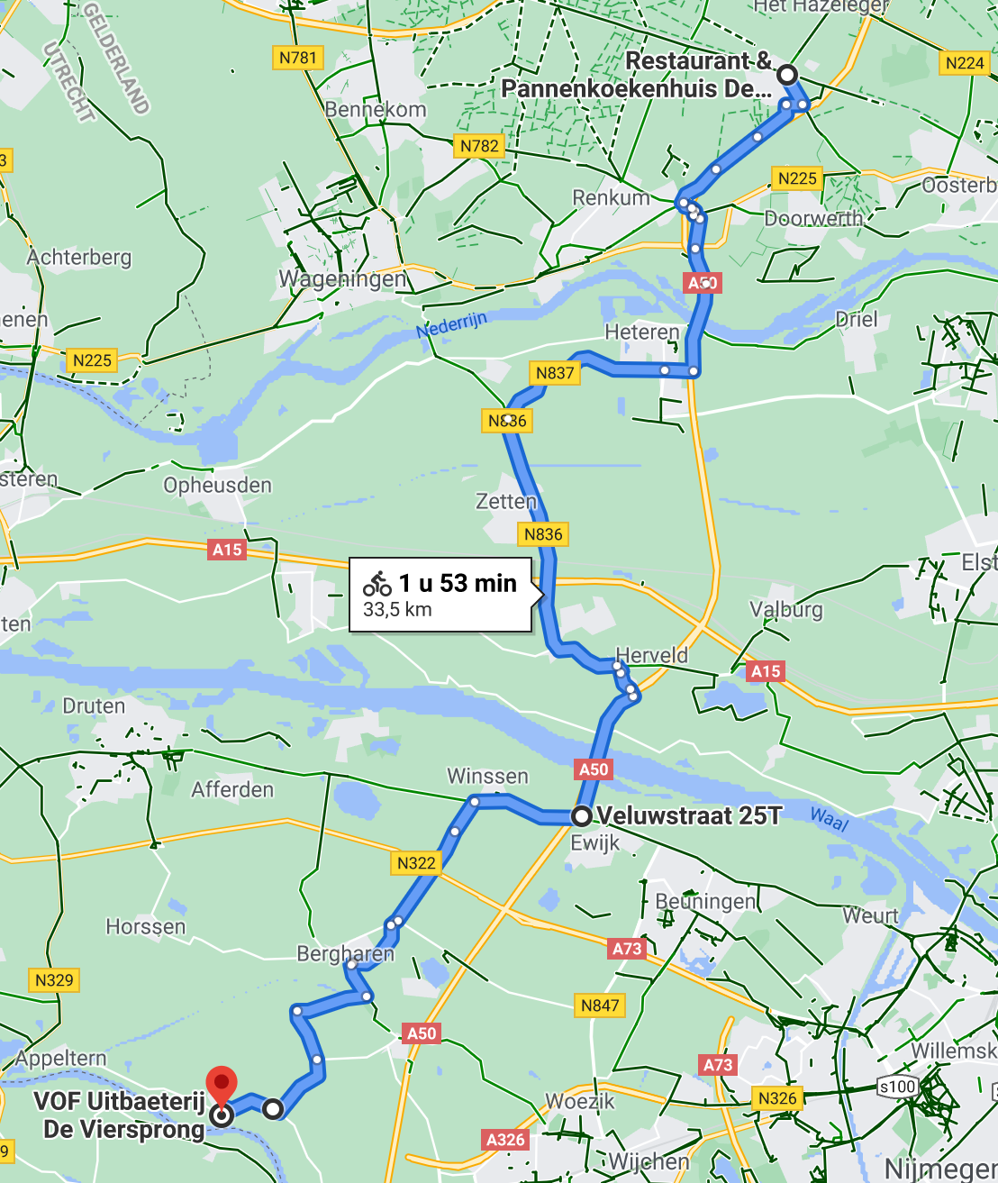
https://www.google.com/maps/dir/Restaurant+%26+Pannenkoekenhuis+De+Tijd,+Wolfhezerweg,+Wolfheze/51.8746853,5.733493/V.O.F.+Uitbaeterij+De+Viersprong/@51.912452,5.6443262,11.42z/data=!4m30!4m29!1m15!1m1!1s0x47c7aef6380b36e5:0x4567b2916fec1faf!2m2!1d5.7922511!2d52.0051874!3m4!1m2!1d5.796672!2d51.9999484!3s0x47c7aef755212de3:0x62254655f56715a2!3m4!1m2!1d5.7919245!2d51.9991091!3s0x47c7aef11dbaf22d:0xb3a5ec06042972f2!1m5!3m4!1m2!1d5.6453831!2d51.8230794!3s0x47c701be0397fcfd:0x52a31a49ed6e8bb0!1m5!1m1!1s0x47c701e9be66612f:0xae34e2ad1d4f35d2!2m2!1d5.6307275!2d51.821872!3e1!5m1!1e3

3e stop Theetuin “Onder de Groene Hemel” 16 km
Doorbraakdijk 11, 6626 KD Alphen
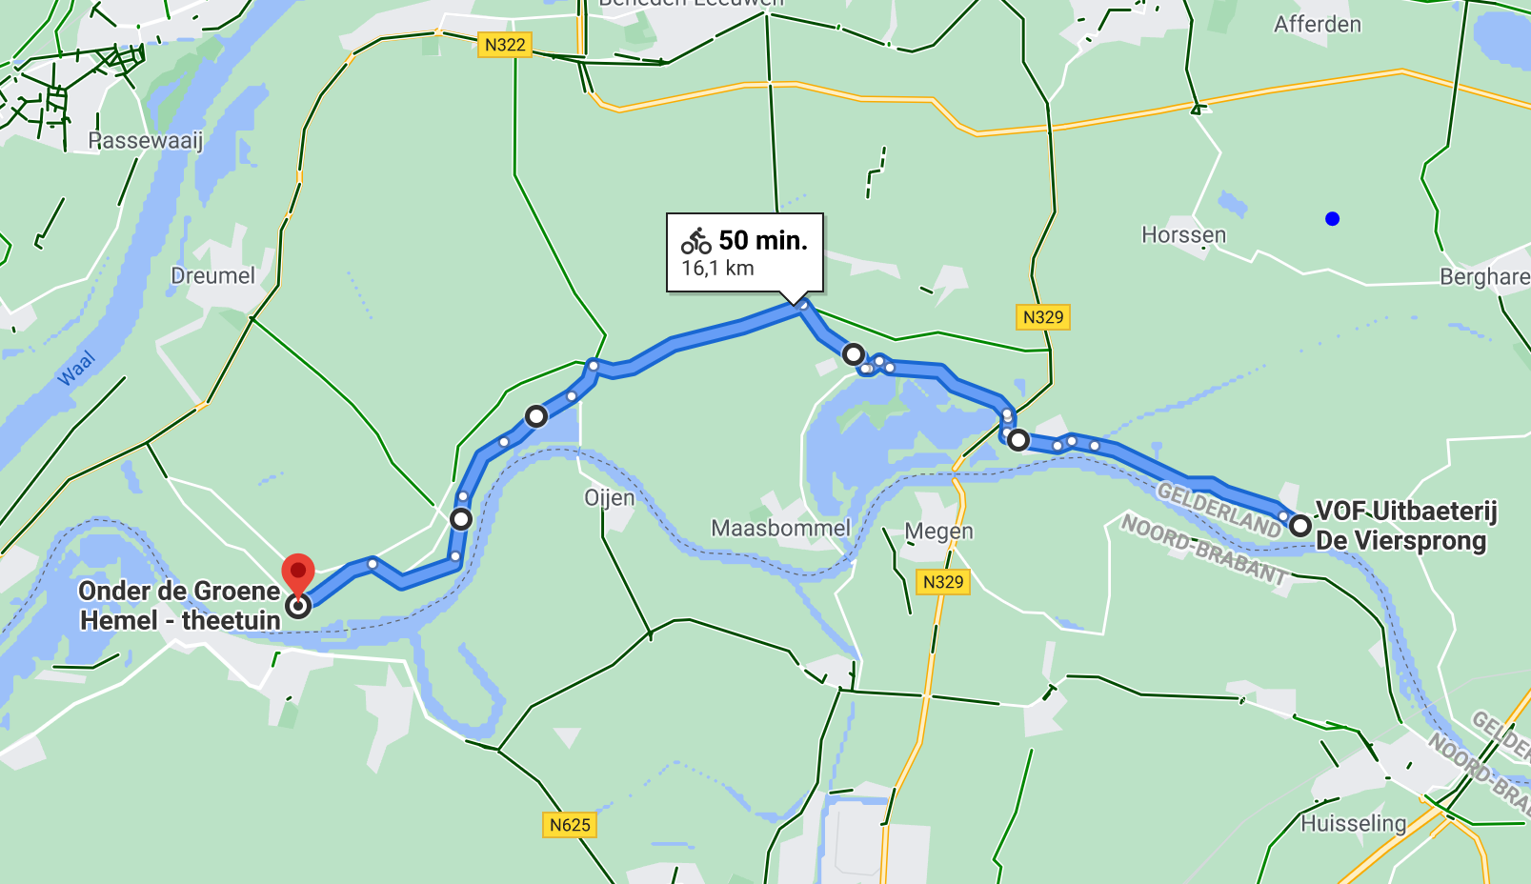
https://www.google.com/maps/dir/V.O.F.+Uitbaeterij+De+Viersprong,+Grootestraat,+Batenburg/Onder+de+Groene+Hemel+-+theetuin/@51.8312208,5.489867,12.57z/data=!4m34!4m33!1m25!1m1!1s0x47c701e9be66612f:0xae34e2ad1d4f35d2!2m2!1d5.6307275!2d51.821872!3m4!1m2!1d5.5783351!2d51.8317517!3s0x47c6fe4470ce4c9f:0xe855264d8f862dc2!3m4!1m2!1d5.5478305!2d51.8415192!3s0x47c6fee4f9db8a3f:0xcbc6a98fb80c8b05!3m4!1m2!1d5.4891669!2d51.834446!3s0x47c6f93950632797:0x2f9d22ab6059cde7!3m4!1m2!1d5.4751716!2d51.8227105!3s0x47c6f96939d38b7b:0xfa98f2feecbe2f53!1m5!1m1!1s0x47c6f9873a4c8cf3:0xe737bd4b8705f5b5!2m2!1d5.4449618!2d51.8127665!3e1!5m1!1e3

Op weg naar huis 23 km
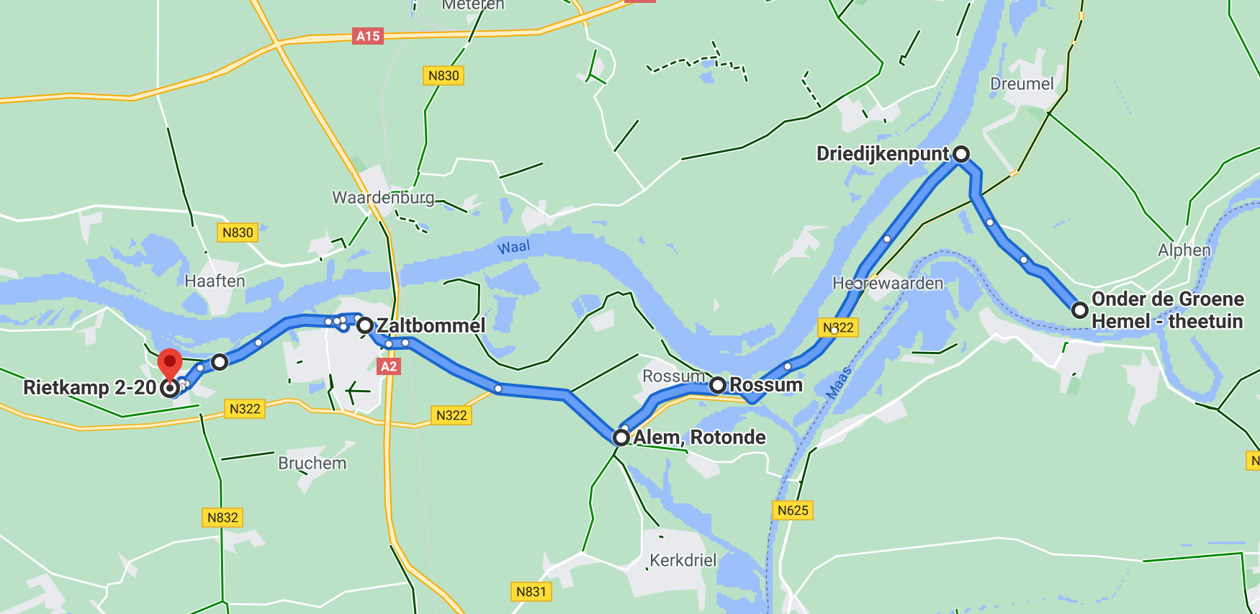
https://www.google.com/maps/dir/Onder+de+Groene+Hemel+-+theetuin,+Doorbraakdijk,+Alphen/51.8388999,5.4128277/51.8003664,5.3471457/51.7913323,5.3211078/51.8102288,5.2520658/51.8041494,5.2129314/51.7998622,5.1994774/@51.7910177,5.3931886,12.58z/data=!4m24!4m23!1m5!1m1!1s0x47c6f9873a4c8cf3:0xe737bd4b8705f5b5!2m2!1d5.4449618!2d51.8127665!1m0!1m5!3m4!1m2!1d5.3465521!2d51.7995781!3s0x47c6f0d8b24af59b:0x2d789cc405f4ab07!1m0!1m0!1m5!3m4!1m2!1d5.2022437!2d51.79995!3s0x47c6f3386c5aa34b:0x9a87b5823cf79dd1!1m0!3e1!5m1!1e3
Aankomst thuis +/- 16.00 uur 101 km

